CIMOPS Process Documentation: Task Movement & Updates
Version History
Date | Approved by | Updates
7th May 2026 | Emily Mc Donald, Rubaasri Subburam | Initial Draft
8th May 2026 | Emily, Pranali and Rubaa | Reviewed/ approved by entire team
13th May 2026 | Emily, Rubaa | Added Bank scenario example
2026-06-01 | Emily | Added info to handle eCUST Batch issues
2026-06-02 | Emily | Updated section on CoNm updates
2026-06-25 | Emily/Pranali | Cleanup procedures for CoNm updates.  Add Canadian numbered company research and examples

Note: All team members will follow a standardized process to ensure that every account accessed by any resource is accurately recorded in the Oracle tables together with the corresponding employee’s name.
Step 1: Start the Task
- Open the Daily Task Log (Excel) - sent via email to all CIMOPS users. Users assign these tasks to themselves as needed in the CIMOPS Queue Mgmt screen.
- Filter by assigned Employee Name
- If any of the following fields are blank, the task should be validated as ‘No DUNS Match’ in CIMOPS Portal and must not be moved.
- Account Company Name or DUNS Company Name
- Account Address or DUNS Address
- Filter the OkAddr & OkCoNm.
- If the flag is Y-Y, then update the flag column to m for those rows (m flag=move only). The team should do a quick review of these. These are good matches, based on the comparison of the first 10 characters after the standardization (that includes stripping of spaces and punctuations). If the team finds bad matches on these, please share examples with Emily.
- Evaluate the addresses first then Evaluate the Company name
- Pick the remaining tasks and begin analysis

Step 2: Detailed Address validation:
- Street name – should be exact match
- Street number - should be exact match
- US - Postal code first 5 should be an exact match
- CA - the entire Postal code should be an exact match
- City - If postal and street names are exactly same, City names can be different owing to preferred and non-preferred city names. (Low priority on city names). But if postal code is different evaluate the full address including city.

Address Flag Review
- If the OkAddr flag is Y then colour code those addresses
- If the Address are not Y then we need to review the address if street name, street number and postal code all are match then it is an address match. Colour code those with the same colour used prior.
- If the address is not a match, then it is not a good move. Add ‘n’ in the column “Flag”.
- For those EANs which passed the address check, Filter those colour coded rows.

Case 1 – Abbreviations in Address
Consider whether it’s the same street when comparing the account to the Duns. Either of these fields may show abbreviations.
French Canadian address may show different words and abbreviations for the address. For example, these addresses match:
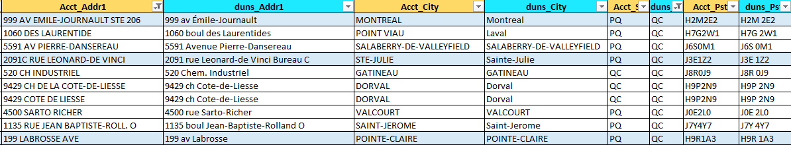

Case 2 – Directionals (N/S/E/W)
If the direction is different/missing in Address line1- then don’t move (Subject to change in future though)
Case 3 – Suite number
Canadian Addresses - Suite number is in the beginning. Find those where the street name/number is matching. Suite number doesn’t have to match. Do not remove the suite number.
US Addresses – May have suite number in the account address - Do not change or remove the suite number from the Address. Also do not move it to the secondary unit field.
Note: in some cases, suite# may be appended to the Street#. This would still be a match.

Step 3: Company Name Validation (only if address is valid)
Company Name review
- Make sure you’ve validated the address as mentioned in Step 2. If address is not a match then no need to review the company name.
- Compare the EAN company to the Duns company name or any of the Duns Tradestyles. Tradestyles may give exact match or link both the company names.
- Research may still be needed for the EANS matching with TS not Duns company name.
- Use caution when Company Name includes the city name/ country name (which may be shown in the address). Do not assume it's a match. Determining if it’s a good match should not be based on the city/ country name only.
- Mall Locations - Use extreme caution with Mall tasks to ensure that the account is a match to the Duns. Example: If the account refers to an actual store (i.e. Nike) and the Duns refers only to the Mall name or a different store name at the same mall, it is NOT a match.
- In case of law firms, research must be performed to ensure it’s the same law firm. At least two lawyer names should be matching (if more than one shown on the account). If first and last name is not clearly the same research is needed and if you are not confident do not move it.
- For Banks - bank mergers and acquisitions are common. Some company name similarities may legitimately result from historical mergers.
- In cases where the company name is heavily abbreviated, CESE (CHT Hierarchy) data may help to determine account ownership.

CESE Data Research – for heavily abbreviated accounts (or other uncertainties)
Search for the EAN# in the Task Log ‘CESE Data’ tab, then check the ‘CESE_GE_NM’ field. For the below example it helps prove that ‘WF Connect San Fran’ belongs to Wells Fargo.
Task detail:

CESE Data tab:
**Please note that the ‘Y/Y’ columns on the CESE Data tab refer to the type of CESE hierarchy - Contract Entity (CE) vs Sales Entity (SE). They do not indicate whether it’s a good Duns match.

Canadian Companies with Numbered Legal Entity - Analysis
- Numbered Canadian corporations require thorough research because their corporate names alone do not reveal ownership, control, business operations, or affiliations.
- Determining whether entities are related requires reviewing official corporate records, ownership structures, directors, officers, and historical filings. In the absence of direct documentary evidence, separate legal entities should not be assumed to be affiliated based solely on indirect indicators such as similar names or shared addresses.
- Numbered Canadian companies may include the name of ‘CANADA’ or any of its Provinces or territories (province codes):
  - Alberta (AB)
  - British Columbia (BC)
  - Manitoba (MB)
  - New Brunswick (NB)
  - Newfoundland and Labrador (NL)
  - Nova Scotia (NS)
  - Ontario (ON)
  - Prince Edward Island (PE)
  - Quebec (QC or PQ)
  - Saskatchewan (SK)
  - Northwest Territories (NT)
  - Nunavut (NU)
  - Yukon (YT)

Example 1:
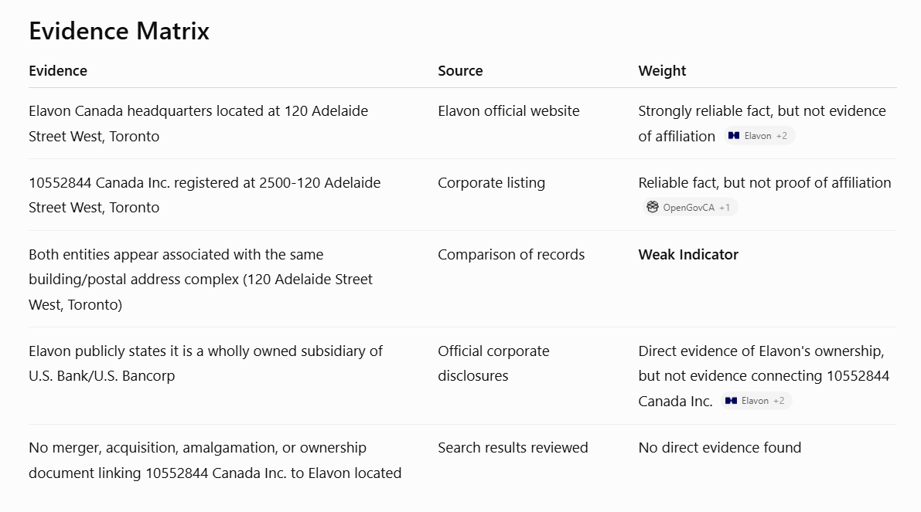
Based solely on the evidence currently located, there is insufficient documentary evidence to conclude that Elavon Canada and 10552844 Canada Inc. are legally related.
Proven facts:
- Elavon operates from 120 Adelaide Street West in Toronto and is part of the U.S. Bank/U.S. Bancorp corporate group.
- 10552844 Canada Inc. was incorporated on December 21, 2017 and has been publicly listed at 2500-120 Adelaide Street West, Toronto.

Conclusion: ‘No Duns Match’ - The shared address constitutes only a weak indicator and does not satisfy the evidentiary threshold necessary to establish a legal corporate relationship.

Example 2:
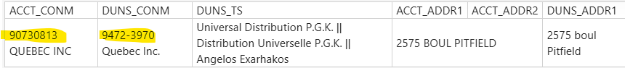
Research findings:
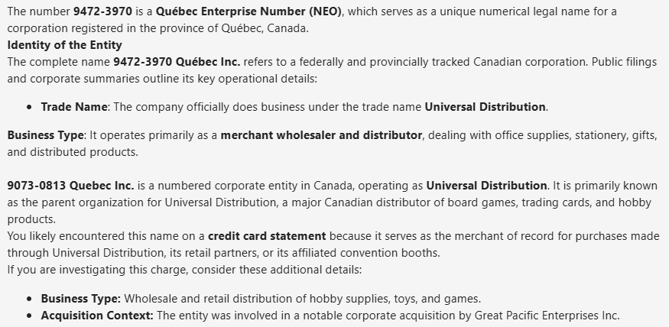
Conclusion: ‘Duns Match Found’ – based on the research which supports ‘Universal Distribution’ as a valid Tradestyle for 90730813 Quebec Inc.

Other examples - Research needed
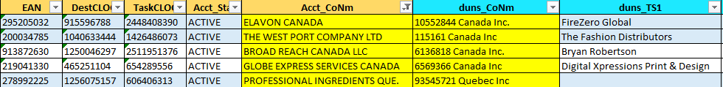

Scenarios or guidelines for Company Name changes:
- Don't need to make company name changes if 'No Duns Match'
- If retail store/ warehouse location/ distribution centre, store# can be edited and processed using the Store# batch template. Clean up Company Name if needed (remove tokens like ‘store, retail, city name’, etc if not part of legal name). Format for Store# updates as follows “Walmart # 1234”. Add ‘c’ to the flag column.
- NO need to add Corp, LLC, Inc, etc to Company name or extra punctation, as these are ignored for matching purposes.

Examples:
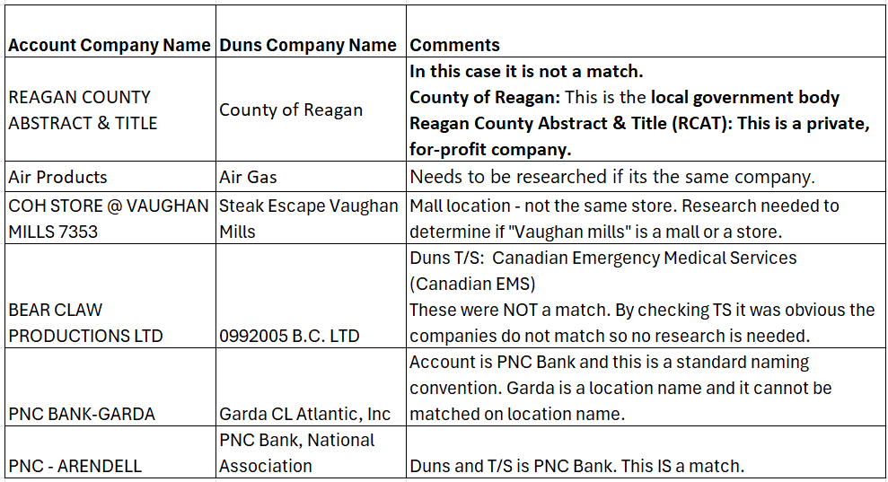

Step 4: Updates to be done only if it has a Duns match and is likely to trigger a direct match
- Phone Number: If phone number is blank, please populate it with 1800-463-3339 before trying to update other attributes.
- Store # update: Done in the company name field. Format for Store# updates as follows “Walmart # 1234”.
- EC Contact updates: EC contacts need not be touched. These attributes are not displayed in the task log / Excel spreadsheet. It is not necessary to update these attributes in order to move the account. EPA contacts can still be updated using Ecust Batch without populating EC contact attributes.

Step 5: Python scripts
- Ensure flags are updated for all EANs.
- Save the excel sheet with the required naming convention in the designated folder.
- Run the python script and batch jobs should be created for Ecust batch job and EAN moves. Check that the batch jobs are created.
- Make sure that all accounts are recorded in Oracle tables.

Step 6: eCUST Batch and EAN Move jobs
- Keyword - Ecustbatch URL: https://ecust.prod.cloud.fedex.com/ecustbatch/jsf/businessUserLandingPage.xhtml?faces-redirect=true
- If needed, submit the phone number file first, wait until processing is done.
- Submit remaining files for Company name and Store#.
- Once all the ecust batch files have processed, then process the EAN move files in the CIMOPS portal.

Step 7: Final Validation
- Python script will verify if the updated EANs are in the correct Duns CLOC or if an additional move is needed.
- Run automated validation (separate python script). Task validation comments will be applied as follows –
- Duns match found – flag will be ‘m’, ‘c’ or ‘a’
- No Duns match Found – flag will be ‘n’
- Partial Duns match - flag will be ‘m’, ’n’
- Need to document the python script used for the task validations.
- There could be some tasks in their inbox where accounts remaining are FDFR-only and should not be updated. Users must check their inbox for these. These tasks will also be listed on the ‘Pending Validations’ tab.

Step 8: Final Checks
- Confirm updates, moves, and validation are completed.
- Make sure no tasks are left unattended in your inbox.
- Assign additional tasks from the Queue management screen.

Appendix: Add links to the following:
- Detailed Python script documents
- QC procedures and Dashboard

